POSTPARTUM DEPRESSION PREDICTION USING MACHINE LEARNING ON CLINICAL AND BEHAVIOURAL DATA

ABSTRACT
Postpartum Depression (PPD) is one of the most common mental health issue affecting new mothers around the globe. During the past years, the number of PPD patients have increased significantly. Yet, the stigma remains. A large number of PPD cases goes undiagnosed. It may be due to the persisting stereotypes around mental health, lack of awareness, and inadequate support system. However, early prediction of PPD is important for the maternal well being of the mother. Timely intervention can prevent the severity of the symptoms, and chronic depression. This study uses machine learning for prediction of postpartum depression by analysing clinical and behavioural data. The study has been divided into two tasks. One, prediction of postpartum depression using classification methods. Second, prediction of postpartum depression using regression methods. Later on, we’ll be comparing the results and conclusions from both the models.
For the classification models, Edinburgh Postnatal Depression Scale (EPDS) result is considered as the target variable. The goal was to group EPDS result into three risk levels: low, medium, and high. Machine Learning models like Decision Tree, Random Forest, and XGBoost are used for this. These models were trained on a collected dataset and evaluated for accuracy, precision, recall and F1 score. The Decision Tree model achieved 94% accuracy. The Random Forest classifier outperformed the Decision Tree with 97% accuracy. XGBoost also reached 97% accuracy. For the regression models, EPDS score was considered as the target variable. ML models like Random Forest, GridSearchCV on Random Forest, and GridSearchCV on Linear Regression. The evaluation focused on Mean Squared Error (MSE), Mean Absolute Error (MAE), and R² score. The Random Forest model had an R² of 0.926. The GridSearchCV Random Forest model also had an R² of 0.926. The GridSearchCV on Linear Regression model had lower performance overall, with an R² of 0.91.
Our findings through this study not only helps in identifying and predicting PPD risk but also provides valuable insights for early intervention strategies and better mental health outcomes. This research not only highlights the potential of integration of Machine learning algorithms into the medical field to enhance its effectiveness in preventing PPD risk but also contributes to the growing field of AI assisted diagnosis in India.
Keywords: Postpartum Depression, Machine Learning, Classification, Regression, Decision Tree, Random Forest, XGBoost, Linear Regression, GridSearchCV, EPDS, Clinical Data, Behavioral Data, Mean Squared Error, Mean Absolute Error

INTRODUCTION
Postpartum depression (PPD) is one of the most common yet serious issues that can affect new mothers after childbirth. According to MDPI (2025), PPD affects about 10-20% new mothers worldwide. In reference with (CDC, 2024), it is estimated that 1 in 8 women in United States will experience PPD symptoms. Thus, making it an urgent public health issue. Apart from the immediate impact on the emotional and psychological well being of a woman, PPD can also adversely affect a new born’s cognitive growth and emotional bonding. It can also put a strain on marriages and increase the risk of family instability. Hence, PPD not only negatively impacts the mental health of the mother but also has long term consequences on child development and family dynamics (BMC Public Health, 2024).
Despite the urgency, nearly 50% of PPD cases go undiagnosed or untreated. This is often due to underreporting, lack of awareness, cultural stigma, and limited access to diagnosis and treatment, especially in areas with low resource availability (NCBI, 2018). This lack of screening the delays vital care needed by mothers and worsens infant development. The causes of postpartum depression are complex. They involve a mix of biological, psychological, and social factors. The Centers for Disease Control and Prevention (CDC) and the National Institutes of Health (NIH) point to biological factors like significant hormonal changes after childbirth, thyroid problems, and genetic influences. Psychologically, women with a history of depression or anxiety, unexpected pregnancies, or experiences of miscarriage are at higher risk. Social factors includes such as lack of support from partners or family, financial issues, troubled marriages, and exposure to domestic violence. The Edinburgh Postnatal Depression Scale (EPDS) is the most commonly used diagnosis tool in clinical treatment (Perinatology, 2025). Most traditional assessment tools focus on symptoms and often overlook the broader context affecting a mother's mental health. Recent studies suggest that using a more holistic approach, which includes clinical, behavioral, and social information, can greatly improve PPD detection accuracy. Factors like maternal age, education level, family structure, household income, pregnancy complications, breastfeeding habits, support from family and partners, and the newborn's health all impact the onset and severity of postpartum depression.

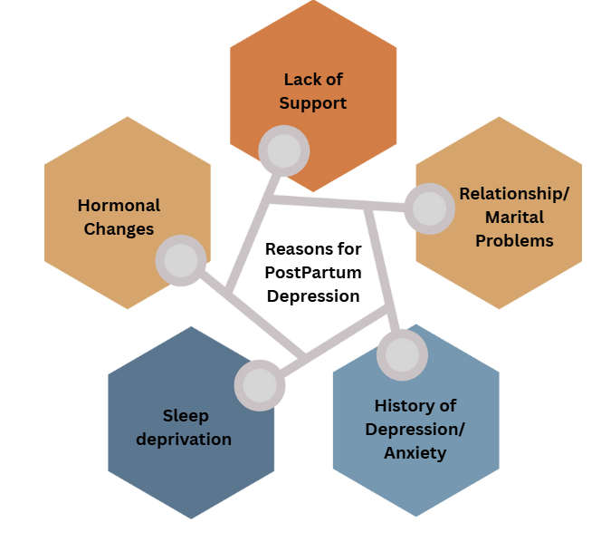

Figure1. Reasons for Postpartum Depression
If left untreated, postpartum depression (PPD) can lead to serious and long lasting consequences that affect not only the mother but also her child and family as a whole. For mothers, the condition can significantly increase the risk of chronic depression, anxiety disorders, social withdrawal, and substance abuse. In more severe cases, untreated PPD can result in suicidal thoughts or actions—tragically, suicide remains one of the leading causes of maternal mortality within the first year after childbirth, according to the National Institutes of Health (NIH, 2023).
The impact of maternal depression extends well beyond the mother herself. Infants born to mothers with untreated PPD are at a higher risk of experiencing a wide range of developmental challenges. These may include delayed cognitive development, language acquisition issues, and difficulties in emotional regulation. In addition, impaired mother-infant bonding during the critical early months of life can contribute to attachment disorders, behavioral problems, and social difficulties as the child grows. According to the World Health Organization (WHO, 2023), children exposed to maternal depression are also more likely to suffer from malnutrition, stunted growth, and lower academic achievement later in life.
The dual burden of untreated PPD—on both maternal well-being and child development—highlights the urgent need for early and accurate identification of at-risk mothers. Timely intervention not only improves health outcomes for the mother but also lays the foundation for healthier emotional and developmental trajectories for the child. Addressing PPD promptly through a combination of screening, supportive care, and treatment can break the cycle of intergenerational mental health challenges and promote more resilient families and communities.
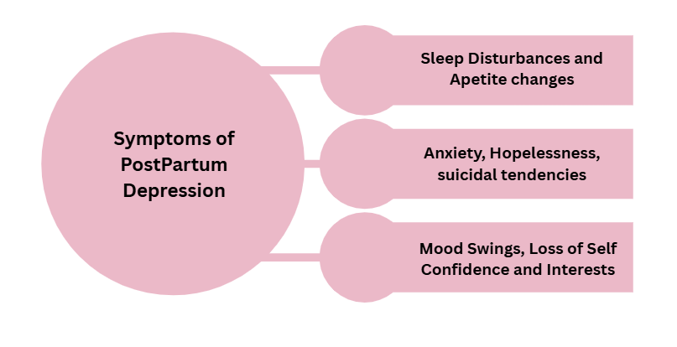
Figure2. Symptoms for Postpartum Depression
Recent advances in machine learning (ML) have created promising opportunities to bring together a wide range of factors—biological, psychological, social, and clinical—into integrated, data-driven models for predicting postpartum depression. Previous studies have demonstrated that ML models trained on such diverse data can achieve high accuracy, with area under the curve (AUC) values reaching up to 0.86, effectively identifying mothers at risk of developing PPD (Translational Medicine, 2025). In particular, ensemble learning techniques like Random Forest and XGBoost have shown great strength in capturing the complex and often non-linear relationships present in these multifaceted datasets.
In our study, we analyze a rich dataset that includes demographic information, clinical history, behavioral patterns, relational dynamics, and psychosocial factors. This dataset covers maternal health history, the level of family and spousal support, pregnancy-related details, newborn health outcomes, and scores from widely used screening tools such as the PHQ-2, PHQ-9, and the Edinburgh Postnatal Depression Scale (EPDS). We approach the problem from two angles. First, through regression models, we aim to predict continuous EPDS scores, providing a nuanced view of depressive symptom severity that can help monitor changes over time. This continuous prediction is important because it allows healthcare providers to track subtle shifts in a mother's mental health rather than just categorizing risk. Second, through classification models, we divide EPDS outcomes into distinct risk groups—low, medium, and high—making it easier to prioritize interventions for those who need it most.
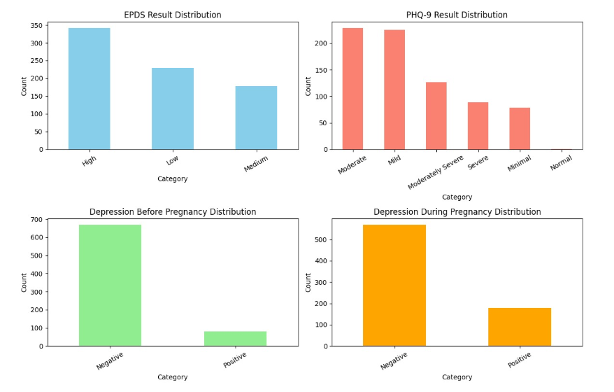
Figure3. Visual Representation of some categorical features using bar graphs
The graphs illustrate the distribution of depression-related assessments across different categories. The EPDS results show that a larger proportion of participants fall into the “High” category, followed by “Low” and then “Medium,” suggesting considerable variation in depressive symptom levels. Similarly, the PHQ-9 outcomes indicate that most participants experienced mild to moderate symptoms, with fewer cases reported in the severe or minimal ranges. When considering depression history, the majority of individuals reported no signs of depression prior to pregnancy, while a small group indicated a positive history. However, during pregnancy, the number of positive cases increased noticeably, though negative cases still remained the majority. Taken together, these findings highlight that while many participants did not report depression before pregnancy, the likelihood of experiencing depressive symptoms increased during pregnancy, underscoring the importance of monitoring maternal mental health.
To build these models, we use several machine learning algorithms including K-Nearest Neighbors (KNN), Decision Trees, Random Forest, and XGBoost. Each brings unique strengths in handling different aspects of the data and prediction tasks. By applying these techniques, we hope to show how machine learning can not only improve early identification of postpartum depression risk but also support better risk stratification. Ultimately, the goal is to enable more timely and personalized interventions that improve health outcomes for both mothers and their children.

Research Objectives
- To analyze clinical and behavioral data from mothers to identify significant patterns that may indicate the risk of postpartum depression.
- To implement machine learning classification models—Decision Tree, Random Forest, and XGBoost—for categorizing individuals into three risk levels: low, medium, and high.
- To evaluate and compare the performance of these classification models using standard metrics such as precision, recall, F1-score, and accuracy.
- To develop regression models to predict continuous EPDS scores, assessing their performance with metrics like R-squared (R²), mean absolute error (MAE), and mean squared error (MSE).
- To identify the most effective algorithms for both classification and regression tasks in postpartum depression prediction based on comparative results.
- To demonstrate the potential of machine learning as a decision-support tool for healthcare professionals in the early detection and intervention of postpartum depression.

LITERATURE REVIEW
Machine learning approaches have increasingly been explored for the detection and prediction of postpartum depression (PPD), a condition strongly associated with adverse maternal outcomes including suicide attempts. Early reliance on psychometric questionnaires such as the EPDS provided only screening-level assessments, but the growing availability of electronic health records (EHRs) and large cohort data has enabled more advanced computational methods. For instance, Zhang et al. (2021) developed a robust PPD risk prediction model using two large EHR datasets—one comprising 15,197 women and the other 53,972 women across multiple sites. Their study demonstrated excellent predictive performance, reporting an AUC of 0.937 in the development dataset and 0.886 in the validation dataset, showing the value of large-scale EHRs for early identification of high-risk mothers.
Similarly, Zhang et al. (2020) investigated model performance using pregnancy-related data from a cohort of 508 women. They created four machine learning prediction models based on two feature selection methods—Random Forest filter selection and expert consultation—and two classifiers, SVM and Random Forest. The best performance was achieved using the SVM combined with FFS-RF, yielding an AUC of 0.78 with sensitivity of 0.69. This highlighted the importance of careful feature selection in improving predictive accuracy even with smaller datasets.
Further, Shin et al. (2020) explored a wide range of algorithms including stochastic gradient boosting, Random Forest, naïve Bayes, SVM, KNN, neural networks, logistic regression, and decision trees. Using 10-fold cross-validation, they found that Random Forest achieved the best performance with an AUC of 0.884, demonstrating the potential of ensemble methods for clinical data. Expanding on population-level studies, Andersson et al. (2021) conducted a prospective cohort analysis in Uppsala, Sweden with 4,313 participants. Among seven ML methods, randomized trees performed best, achieving 73% accuracy, 72% sensitivity, 75% specificity, and an AUC of 0.81. While these results underscored the feasibility of ML in large-scale cohort studies, their model was limited by a relatively low positive predictive value (33%).
Questionnaire-based approaches have also been integrated into ML pipelines. Gopalakrishnan et al. (2022) collected EPDS scores within the first postpartum week and conducted follow-up assessments using PDSS and PHQ-9 up to six weeks. Their analysis identified the Extremely Randomized Trees (XRT) algorithm as most effective, achieving 73% accuracy when combining PHQ-9, PDSS, and background factors. This approach demonstrated the benefits of multimodal self-report data but was constrained by reliance on subjective responses. Finally, Wang et al. (2019) utilized EHRs from Weill Cornell Medicine and NewYork-Presbyterian Hospital (2015–2017), developing six ML models including decision trees, logistic regression, Random Forest, XGBoost, SVM, and naïve Bayes. The SVM achieved the highest predictive performance with an AUC of 0.79, sensitivity of 0.894, and specificity of 0.580. This study further validated the use of EHRs but highlighted challenges with balancing sensitivity and specificity.
Together, these studies indicate that while machine learning holds strong promise for advancing PPD detection, challenges remain regarding dataset imbalance, external validation, and integration of heterogeneous data types. Addressing these gaps could improve early risk stratification and facilitate personalized intervention strategies in maternal mental health.

Author (Year) | Domain of Research | Model(s) Used | Dataset Source | Accuracy / AUC | Limitation
Zhang et al. (2021) | EHR-based PPD risk prediction | ML models (RF, GBM, others) | Two EHR datasets (15,197 women dev; 53,972 women validation) | AUC = 0.937 (dev), 0.886 (val) | Dataset imbalance, generalizability concerns
Zhang et al. (2020) | Pregnancy data & feature selection | SVM + RF (with FFS-RF, Expert selection) | Cohort of 508 pregnant women | AUC = 0.78, Sens = 0.69 | Small sample size, limited scope
Shin et al. (2020) | Multi-model evaluation | 9 ML models incl. RF, SVM, KNN, NN | Clinical + survey data, 10-fold CV | RF best, AUC = 0.884 | Overfitting risk, single-country dataset
Andersson et al. (2021) | Population cohort (Uppsala, Sweden) | 7 ML methods, Randomized Trees best | 4,313 participants, prospective cohort | Acc = 73%, AUC = 0.81 | Low PPV (33%), limited external validation
Gopalakrishnan et al. (2022) | Questionnaire data (EPDS, PHQ-9, PDSS) | XRT (Extremely Randomized Trees) | Indian mothers, postpartum week 1–6 | Acc = 73% | Limited to self-reported data
Wang et al. (2019) | EHR-based predictive modeling | 6 ML models (DT, LR, RF, XGB, SVM, NB) | EHRs (2015–2017, Weill Cornell & NYP) | SVM best, AUC = 0.79, Sens = 0.894 | Specificity low (0.580), dataset limited to US hospitals
Table 1. Summary of the existing relevant work in the domain

Unlike many previous studies that focus solely on classification to identify postpartum depression risk, our approach combines both classification and regression models to provide a more comprehensive assessment. By predicting continuous EPDS scores alongside risk categories, we capture not only the presence but also the severity of depressive symptoms. Additionally, we incorporate a wider range of clinical, behavioral, and psychosocial variables and evaluate multiple machine learning algorithms—Decision Tree, Random Forest, and XGBoost—using both classification and regression metrics. This dual approach enhances early detection accuracy and offers nuanced insights, potentially enabling more personalized and timely interventions for mothers at risk of PPD.

METHODOLOGY

Dataset Description
This study utilizes a publicly accessible dataset from Kaggle containing clinical, demographic, and behavioral information of postpartum mothers. The dataset comprises a wide range of attributes, including age, residence, education, marital status, occupation and income (both for the mother and spouse), addiction history, medical history, pregnancy-related details, newborn information, psychosocial factors, and mental health scores (PHQ9, EPDS).

Feature | Type | Description
Age | Numerical | Age of the mother in years
Residence | Categorical | Urban or rural residence of the mother
Education Level | Categorical | Highest education attained by the mother
Marital Status | Categorical | Marital status of the mother
Occupation before latest pregnancy | Categorical | Mother's occupation before most recent pregnancy
Monthly income before latest pregnancy | Categorical | Mother's income before most recent pregnancy
Occupation after latest childbirth | Categorical | Mother's occupation after childbirth
Current monthly income | Categorical | Mother's current monthly income
Husband's education level | Categorical | Highest education attained by spouse
Husband’s monthly income | Categorical | Spouse’s monthly income
Addiction | Categorical | Any substance addiction (e.g., tobacco, alcohol)
Total children | Numerical | Total number of children mother has
Disease before pregnancy | Categorical | Chronic or non-chronic medical conditions before pregnancy
History of pregnancy loss | Categorical | Previous miscarriage or pregnancy loss
Family type | Categorical | Nuclear or joint family
Number of household members | Categorical | Total members in the household
Relationship with in-laws | Categorical | Quality of relationship with in-laws
Relationship with husband | Categorical | Quality of relationship with husband
Relationship with newborn | Categorical | Quality of mother-newborn bonding
Relationship between father and newborn | Categorical | Quality of father-newborn bonding
Feeling about motherhood | Categorical | Mother's overall sentiment toward motherhood
Received support | Categorical | Whether mother received social/family support
Need for support | Categorical | Mother's perceived need for support
Major changes/losses during pregnancy | Categorical | Any significant life events during pregnancy
Abuse | Categorical | Experience of abuse during or before pregnancy
Trust and share feelings | Categorical | Ability to share feelings with others
Number of the latest pregnancy | Numerical | Current pregnancy number (parity)
Pregnancy length | Categorical | Duration of latest pregnancy
Pregnancy plan | Categorical | Whether the pregnancy was planned
Regular checkups | Categorical | Frequency of prenatal checkups
Fear of pregnancy | Categorical | Maternal fear or anxiety about pregnancy
Diseases during pregnancy | Categorical | Any medical conditions developed during pregnancy
Age of newborn | Categorical | Age of the most recent child
Age of immediate older children | Categorical | Age of previous child (if any)
Mode of delivery | Categorical | Type of delivery: normal or cesarean
Gender of newborn | Categorical | Male or female newborn
Birth compliancy | Categorical | Any complications during birth
Breastfeed | Categorical | Whether mother breastfeeds the newborn
Newborn illness | Categorical | Any health issues in the newborn
Worry about newborn | Categorical | Maternal concern for newborn health
Relax/sleep when newborn is tended | Categorical | Mother's ability to rest when newborn is awake
Relax/sleep when newborn is asleep | Categorical | Mother's ability to rest when newborn sleeps
Angry after latest childbirth | Categorical | Experience of anger post-delivery
Feeling for regular activities | Categorical | Emotional state during daily routines
Depression before pregnancy (PHQ2) | Categorical | PHQ2 score measuring depression prior to pregnancy
Depression during pregnancy (PHQ2) | Categorical | PHQ2 score measuring depression during pregnancy
PHQ9 Score | Numerical | PHQ9 questionnaire score for depression severity
PHQ9 Result | Categorical | PHQ9 score interpreted as severity level
EPDS Score | Numerical | Edinburgh Postnatal Depression Scale score
EPDS Result | Categorical | EPDS interpreted as low, medium, or high PPD risk
Table 2. Feature summary

Data Preprocessing
To ensure suitability for machine learning models, the dataset underwent comprehensive preprocessing and feature engineering. Missing values were carefully imputed to maintain data integrity, and the dataset was checked for duplicate entries, with none found. Column names were standardized for consistency, and categorical variables with inconsistent entries were corrected. Categorical and ordinal variables were numerically encoded: relationship variables and feelings about motherhood were mapped into ordered scales; PHQ9 and PHQ2 depression scores were numerically represented; binary Yes/No responses were encoded as 1/0; and ordinal categories like Low/Medium/High were mapped to 1/2/3. One-hot encoding was applied to categorical features with multiple categories to make them compatible with machine learning algorithms. Numerical features—including age, monthly incomes, number of children, household members, and pregnancy length—were scaled using StandardScaler to normalize the data and improve model performance. A variance inflation factor (VIF) analysis was conducted to detect multicollinearity; although some features had VIF values greater than 10, removing them decreased model accuracy, so all key attributes were retained except sr (serial number) and age_of_immediate_older_childern to preserve predictive power.

Feature | Original Values | Numerical Encoding
relationship_with_the_in-laws / relationship_with_husband / relationship_with_the_newborn / relationship_between_father_and_newborn | Bad | 1
 | Neutral | 3
 | Poor | 2
 | Good | 4
 | Friendly | 5
 | Very good | 6
feeling_about_motherhood | Sad | 1
 | Neutral | 2
 | Happy | 3
phq9_result | Normal | 0
 | Minimal | 1
 | Mild | 2
 | Moderate | 3
 | Moderately Severe | 4
 | Severe | 5
depression_before_pregnancy_(PHQ2) / depression_during_pregnancy_(PHQ2) | Negative | 0
 | Positive | 1
Binary columns (Yes/No responses) | Yes | 1
 | No | 0
Ordinal columns (Low/Medium/High) | Low | 1
 | Medium | 2
 | High | 3
Table 3. Numerical Encoding for key features

After careful preprocessing and feature engineering, the final curated dataset is clean, well-organized, and ready to be used for training machine learning models. It includes a comprehensive range of important factors—demographic, clinical, behavioral, and psychosocial—that are relevant to predicting postpartum mental health. This dataset is suitable for both classification tasks, such as grouping mothers into low, medium, and high risk for postpartum depression, and regression tasks, like predicting continuous clinical scores, enabling a thorough and nuanced analysis.

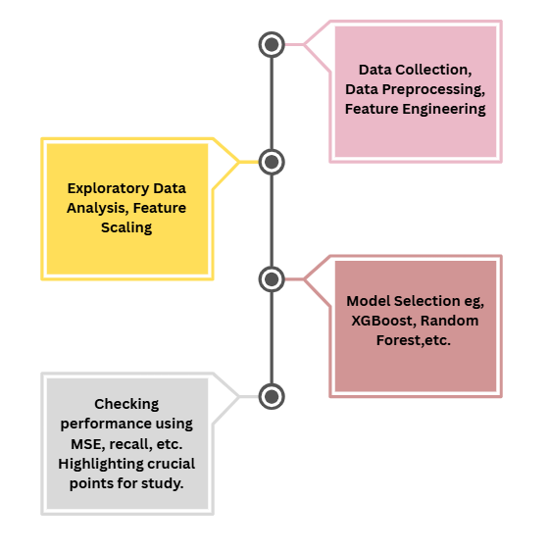
Figure4. Transformational Flow

Exploratory Data Analysis (EDA)

To gain deeper insights into the distribution and relationship patterns across mental health outcomes, a series of visual analyses were conducted. Figure 5(a) highlights the variation in EPDS (Edinburgh Postnatal Depression Scale) results against the levels of perceived support. Interestingly, a high level of support correlates with a noticeable decrease in high EPDS scores, whereas low support is predominantly associated with elevated scores, suggesting a strong inverse relationship between received support and depressive symptom severity. Figure 5(b) explores PHQ-9 (Patient Health Questionnaire-9) outcomes by marital status, revealing a more heterogeneous pattern among married individuals, who exhibit a broader distribution across the severity spectrum. In contrast, divorced participants show a higher concentration in moderate to severe categories. Figure 5(c) investigates the influence of education level on EPDS scores. Although the trends vary, those with university education tend to cluster more in the low-score category, hinting at a potential protective effect of higher educational attainment. Lastly, Figure 5(d) compares EPDS results across marital statuses, where divorced individuals show a pronounced skew toward high depressive symptoms, while married participants are more evenly distributed. These visualizations collectively underscore the multifaceted impact of psychosocial variables—particularly support systems, marital context, and education—on mental health outcomes, supporting the hypothesis that these factors are not only associated with but may also modulate the severity of postpartum depression and general depressive states.

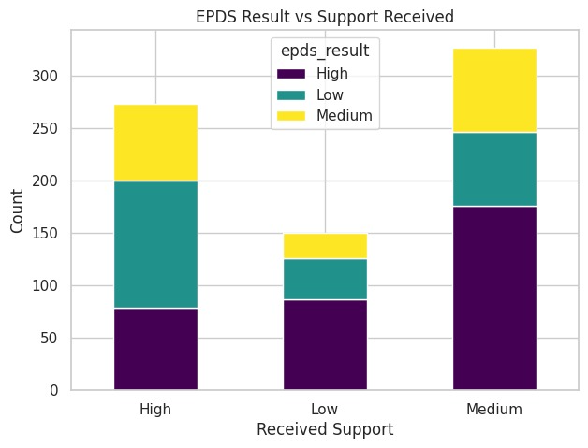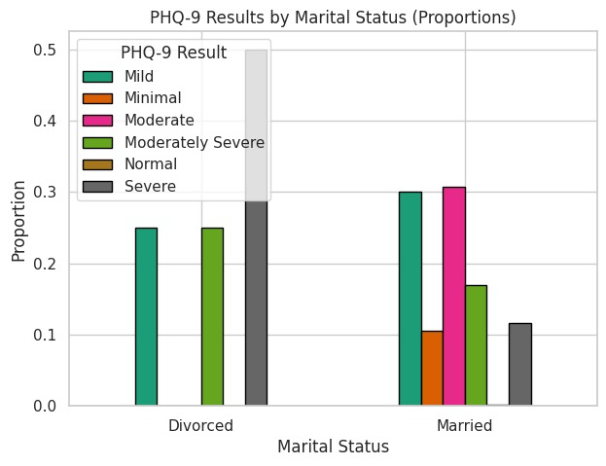
Figure 5(a) Figure 5(b)

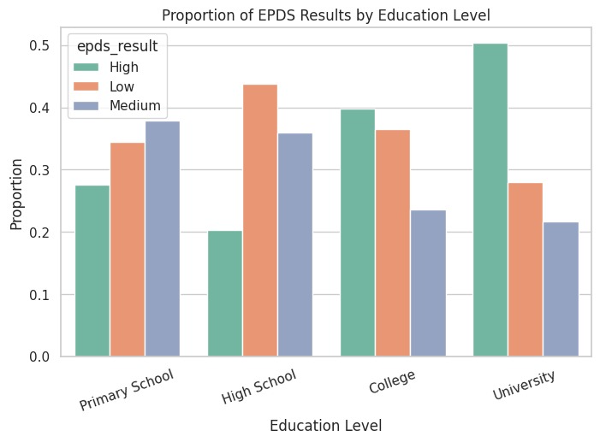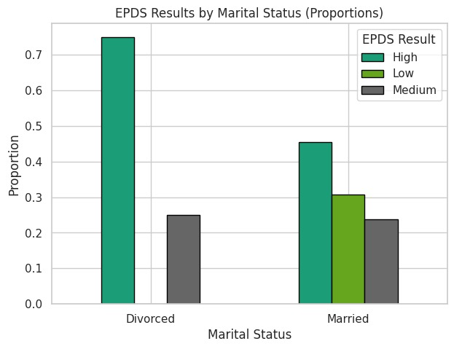
Figure 5(c) Figure 5(d)

Figure 5 (a), (b), (c), (d) shows the visual representation for bivariate data in classification models

To investigate continuous predictors of depressive symptomatology as measured by the EPDS (Edinburgh Postnatal Depression Scale), several regression-oriented visualizations were generated. Figure 6(a) presents the distribution of EPDS scores across different income brackets. While the median scores do not vary drastically across groups, there is a subtle tendency for lower-income groups to report slightly elevated EPDS scores, suggesting income may exert a modest influence on depressive symptoms. A more distinct pattern emerges in Figure 6(b), which compares EPDS scores by marital status. Divorced individuals exhibit notably higher median scores, with a wider interquartile range, indicating both higher and more variable depressive symptoms compared to their married counterparts.
Figure 6(c) examines the relationship between age and EPDS scores through a scatterplot with a regression line. Although the overall trend appears relatively flat, the slight upward slope implies a weak positive association between age and depression scores, warranting further statistical evaluation to confirm its significance. Finally, Figure 6(d) displays EPDS score distributions across education levels. Participants with university education exhibit the highest variability in scores, but individuals with only high school education appear to have the lowest median scores and fewer extreme values. These results suggest education may have a nuanced relationship with postpartum depression, potentially interacting with other socioeconomic or psychosocial factors. Collectively, these visualizations highlight age, income, marital status, and education level as relevant predictors in modeling depressive symptom severity, laying the groundwork for subsequent regression analyses.

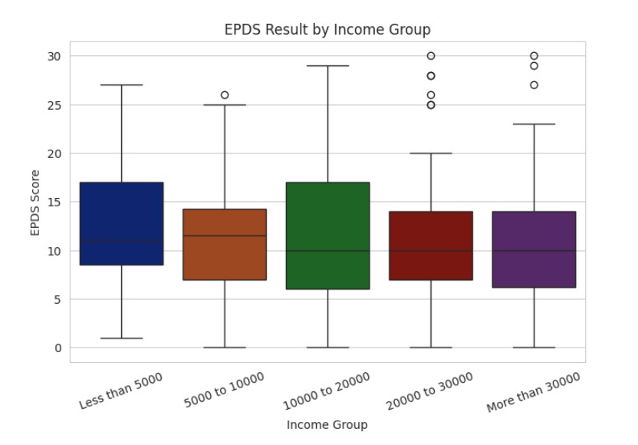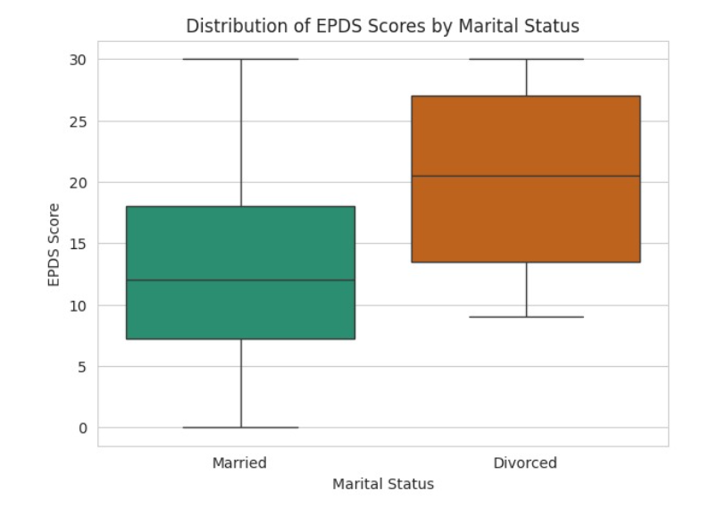
Figure 6(a) Figure 6(b)
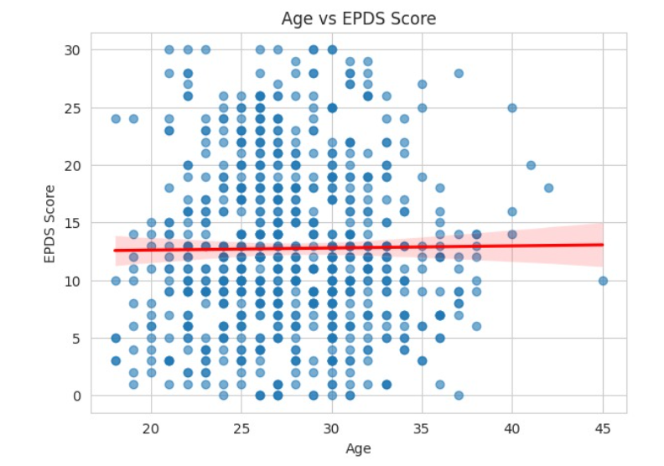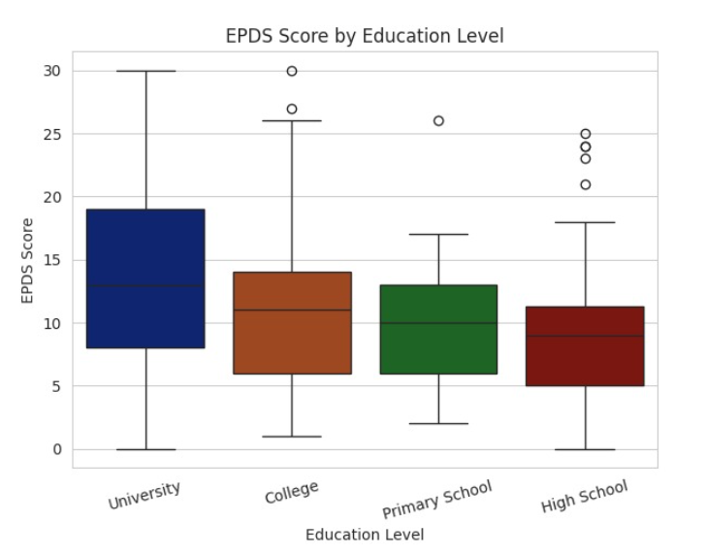
Figure 6(c) Figure 6(d)

Figure 6 (a), (b), (c), (d) shows the visual representation for bivariate data in classification model
To identify variables most strongly associated with depressive symptom severity, a univariate correlation analysis was conducted with the EPDS score as the target. As shown in the heatmap, the phq9_score exhibited the highest positive correlation (r = 0.88), followed by variables such as postnatal anger and fear of pregnancy. Conversely, factors like perceived maternal satisfaction, ability to rest, and history of abuse showed moderate negative correlations. These findings help prioritize key features for classification modeling by highlighting psychosocial and clinical variables with the strongest linear associations to postpartum depression scores. It can be referred from figure 7.

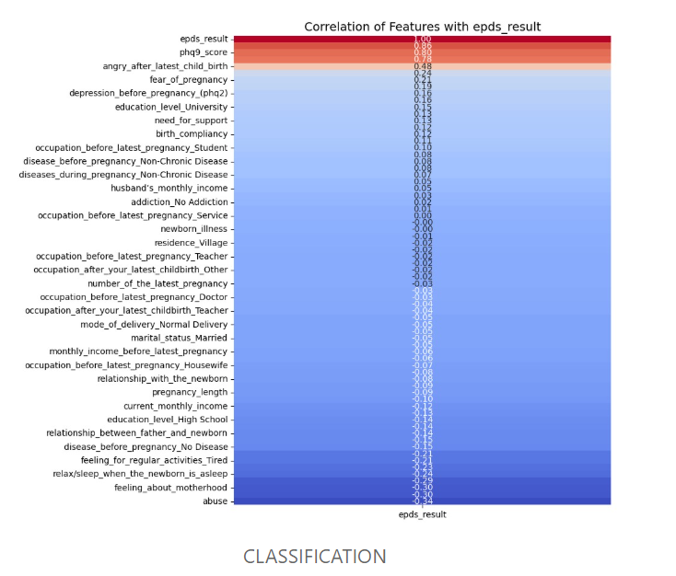
Figure 7. Correlation Matrix for Classification

To support the regression analysis of postpartum depression severity, a feature-wise correlation plot was generated using the EPDS score as a continuous outcome variable. As shown, the phq9_result demonstrates the strongest positive correlation (r = 0.89), reinforcing its predictive alignment with depressive symptoms. Additional positive associations were observed with variables such as postnatal anger, antenatal depression, and support needs. On the other hand, negative correlations were noted for relational and social factors, including poor spousal relationships, lack of emotional support, and prior abuse (r = –0.40). These insights assist in identifying both risk and protective factors, guiding feature selection for regression modeling. It can be referred from Figure 8.

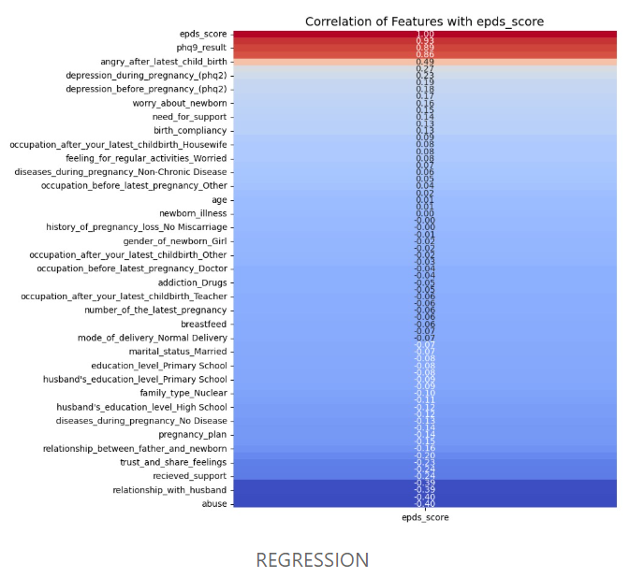
Figure 8. Correlation Matrix for Regression

Model Architecture
In this study, separate models were designed for classification and regression tasks related to postpartum depression (PPD). For classification, Decision Tree, Random Forest, and XGBoost were used. The Decision Tree served as a simple baseline, Random Forest was selected to improve generalization through ensemble learning, and XGBoost was included for its ability to model complex non-linear interactions. Hyperparameters were tuned using GridSearchCV with five-fold cross-validation. For Decision Tree, parameters such as maximum depth, minimum samples split, and minimum samples per leaf were optimized. For Random Forest, the number of trees (n_estimators), tree depth, split criteria, and maximum features were tuned, while XGBoost parameters included learning rate, estimators, maximum depth, and subsampling ratio.
For regression, the objective was to predict continuous PPD outcomes (EPDS scores) using three models: Random Forest, a tuned Random Forest, and a tuned Linear Regression. Random Forest was optimized for parameters like number of estimators maximum depth, minimum samples split, and minimum samples per leaf, while Linear Regression tuning involved intercept and positivity constraints.
All experiments were implemented in Python using scikit-learn for Decision Tree, Random Forest, and Linear Regression, and the XGBoost package for gradient boosting, with pandas and NumPy supporting data preprocessing.

Evaluation Metrics
To assess the performance of the models, different evaluation metrics were applied for classification and regression tasks. For classification, accuracy, precision, recall, and F1-score were used to provide a balanced view of performance, as relying on accuracy alone can be misleading in the presence of class imbalance. Precision and recall helped capture the trade-off between false positives and false negatives, while the F1-score offered a single measure that balances both. For regression models, the primary metric was the coefficient of determination (R²), which indicates how well the model explains variance in the data. In addition, Mean Absolute Error (MAE) and Mean Squared Error (MSE) were calculated to measure the average and squared differences between predicted and actual values, with MAE being more interpretable and MSE penalizing larger errors more heavily. Using this combination of metrics ensured a comprehensive evaluation of both predictive accuracy and model reliability.

Experimental Setup
All experiments were carried out in Python, making use of widely adopted libraries such as scikit-learn for model implementation, pandas and NumPy for data handling. For the classification and regression tasks, the dataset was divided into training and testing sets with a standard 70:30 split, ensuring that the models were trained on the majority of the data and evaluated on unseen samples. To further reduce the risk of overfitting and to fine-tune hyperparameters, five-fold cross-validation was applied within the training data using GridSearchCV. This approach provided a more reliable estimate of model performance by averaging results across multiple folds rather than relying on a single split. Overall, this setup ensured a fair balance between computational efficiency and reliable evaluation, while also making the experiments reproducible in a standard machine learning environment.
RESULTS
Model | Accuracy | Precision | Recall | F1-Score
Decision Tree | 0.94 | 0.95  0.88  0.96 | 0.91  0.87  1.00 | 0.93  0.88  0.98
Grid Search CV on Random Forest | 0.97 | 0.X | 0.XX | 0.XX
XGBoost | 0.97 | class 1 low- .98  2 med- 0.90  3 high- 1.00 | 0.91  0.98  1.00 | 0.95  0.94  1.00
Table 4. Classification Models Performance
Model | R² | MAE | MSE
Random Forest | 0.92 | 1.50 | 3.82
Grid Search CV on Random Forest | 0.92 | 1.51 | 3.81
Grid Search CV on Linear Regression | 0.90 | 1.72 | 4.70
Table 5. Regression Models Performance
DISCUSSION
Interpretation of results
The evidence strongly suggests that untreated postpartum depression has wide-reaching consequences for both mothers and their children. For mothers, the risks extend far beyond the postpartum period, often developing into chronic mental health disorders or leading to life-threatening outcomes such as suicide. For children, the findings emphasize how maternal mental health is closely tied to early cognitive, emotional, and social development. Together, these results highlight the intergenerational nature of untreated PPD, where one individual’s health condition can ripple outward to affect the well-being of an entire family.
Limitations of the current work
While the findings underline the seriousness of untreated PPD, this discussion is limited by its reliance on secondary data from existing reports (e.g., NIH, WHO). Without direct primary research or longitudinal data collection, the conclusions are based on aggregated findings rather than firsthand analysis. Cultural and socioeconomic factors, which often shape the way PPD is experienced and treated, were also not fully explored. These limitations suggest that future research should consider context-specific studies to better understand how PPD manifests across different populations.
Insights
One of the more striking insights is the degree to which untreated maternal depression influences child development. While it is expected that a mother’s mental health would affect her bonding with her infant, the long-term consequences—such as stunted growth, malnutrition, and reduced academic performance—are less obvious yet deeply concerning. This emphasizes that PPD is not only a psychological health issue but also a broader developmental and public health concern. The findings carry strong implications for policy and healthcare systems. Early screening for PPD during routine maternal and child health visits could prevent long-term harm. Health systems should integrate mental health services into postpartum care, ensuring that mothers are not only assessed for physical recovery but also for emotional well-being. On a community level, increasing awareness and reducing stigma can encourage more women to seek help. From a policy standpoint, investing in early intervention programs may ultimately reduce healthcare costs by preventing chronic mental health disorders and developmental delays in children.
CONCLUSION
Recap of contributions and findings
This work has examined the far-reaching consequences of untreated postpartum depression (PPD), emphasizing its dual impact on mothers and their children. For mothers, untreated PPD is associated with persistent mental health struggles, including chronic depression, anxiety disorders, and in severe cases, suicidal thoughts and behaviors. These outcomes demonstrate that PPD is not a temporary condition that naturally resolves over time but rather a serious disorder that requires timely medical and psychological attention. For children, the consequences are equally profound. Exposure to maternal depression has been linked to delays in cognitive and language development, poor emotional regulation, behavioral difficulties, and even long-term educational disadvantages. In some cases, maternal depression has also been associated with malnutrition, stunted growth, and weaker immune function. Collectively, these findings underscore that PPD is not simply an individual challenge—it is an intergenerational issue with broad public health implications.
By connecting maternal well-being to child development, this study contributes to a deeper understanding of how untreated mental health conditions can disrupt family systems and create cycles of disadvantage. The evidence highlights the urgent need for early screening, accessible treatment, and supportive care systems that address not only physical recovery after childbirth but also mental health. This holistic perspective is critical in shaping interventions that promote healthier outcomes for both mother and child.
Suggestions for future improvements
Although this discussion highlights important findings, there remain opportunities for improvement in future research and practice. One area of future work involves expanding datasets to include larger, more diverse, and representative populations. Much of the existing evidence is drawn from limited samples or specific regions, making it difficult to fully understand how cultural, social, and economic factors shape the experience of PPD. Broader datasets could provide insights into how PPD manifests across different communities, allowing for more targeted interventions.
In addition, technological approaches hold significant promise. Incorporating machine learning techniques such as transfer learning could improve the accuracy of PPD prediction models, enabling healthcare providers to identify at-risk mothers earlier and more effectively. Similarly, real-time deployment of digital tools—such as mobile health applications, online screening platforms, and AI-driven chat support—could provide immediate assistance to mothers who may otherwise go unnoticed by traditional healthcare systems. These tools could be particularly impactful in low-resource settings, where access to mental health professionals is limited.
Beyond technical improvements, policy-level changes are also essential. Governments and healthcare organizations should prioritize maternal mental health as part of standard postnatal care. This could include mandatory PPD screening during routine checkups, integration of mental health professionals into obstetric and pediatric care teams, and the development of community-based support networks that reduce stigma and encourage mothers to seek help.
Ultimately, this work demonstrates that untreated postpartum depression is both a medical and societal concern, with the potential to shape the trajectory of not only a mother’s life but also her child’s development. Addressing PPD requires collaboration across healthcare providers, policymakers, researchers, and communities. By investing in early detection, innovative technologies, and comprehensive support systems, we can break the cycle of intergenerational mental health challenges and lay the foundation for stronger, healthier families.
REFERENCES
- https://archive.cdc.gov/www_cdc_gov/reproductivehealth/vital-signs/identifying-maternal-depression/index.html
- https://www.cdc.gov/reproductive-health/depression/cdc-activities.html
- https://womenshealth.gov/mental-health/mental-health-conditions/postpartum-depression
- https://www.mayoclinic.org/diseases-conditions/postpartum-depression/diagnosis-treatment/drc-20376623
- https://www.vandrevalafoundation.com/free-counseling
- https://www.cdc.gov/reproductive-health/depression/index.html
- https://www.ncbi.nlm.nih.gov/books/NBK519070/
- https://www.nimh.nih.gov/health/publications/perinatal-depression
- https://www.cdc.gov/pcd/issues/2023/23_0107.htm
- https://policycentermmh.org/maternal-mental-health-fact-sheet/
- https://www.nature.com/articles/s41398-021-01663-6
- https://www.sciencedirect.com/science/article/abs/pii/S187620182100023X
- https://www.frontiersin.org/journals/global-womens-health/articles/10.3389/fgwh.2025.1497740/full
- Centers for Disease Control and Prevention (CDC)
Visit CDC Maternal Mental Health
- National Institutes of Health (NIH)
Visit NIH Perinatal Depression Resources
- World Health Organization (WHO)
WHO: Perinatal Mental Health
- BMC Public Health
Recent PPD Publications - BMC Public Health
- MDPI (Multidisciplinary Digital Publishing Institute)
Latest MDPI PPD Research
- NCBI/NIH (National Center for Biotechnology Information)
NCBI Perinatal Depression Review
- Perinatology/Edinburgh Scale
EPDS Details - Frontiers in Global Women's Health

